杨浦区2015学年度第二学期初三模拟测试
英 语 试 卷
(满分150分，考试时间：100分钟) 2016年5月
考生注意：本卷有7大题，共94小题。试题均采用连续编号，所有答案务必按照规定在答题纸上完成，做在试卷上不给分。
Part 1 Listening (第一部分 听力)
I. Listening Comprehension (听力理解): (共30分)
A. Listen and choose the right picture (根据你听到的内容，选出相应的图片): （6分）
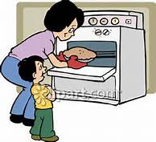  A | 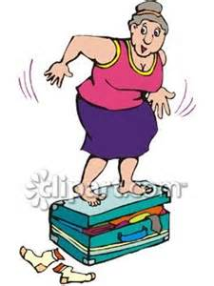  B | 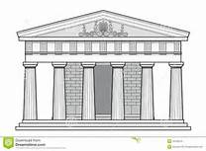  C | 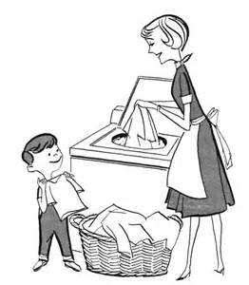  D
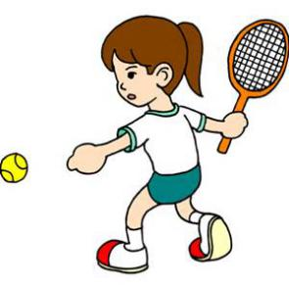 E | F | G | 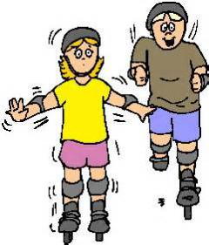  H
- ________ 2. _______ 3. _________ 4. __________ 5. __________ 6. _________
B. Listen to the dialogue and choose the best answer to the question you hear (根据你听到的对话和问题，选出最恰当的答案): (8分)
7. A) By bus. B) By underground. C) By car. D) By taxi.
8. A) Lovely. B) Sunny. C) Rainy. D) Cloudy.
9. A) Bread and juice. B) Newspapers. C) Tomatoes. D) Salad.
10. A) 6:45. B) 7:15. C) 7:30. D) 7:45.
11. A) On the hall table. B) In the car.
C) In his coat pocket. D) In the kitchen.
12. A) She has got a bad headache. B) She is suffering from back pain.
C) She has got a stomachache. D) She has pain all over body.
13. A) Weekend plans. B) TV programs.
C) School subjects. D) Museums and exhibitions.
14. A) Keisha wants to join her neigbhour in the party.
B) Keisha has problems sleeping when it is noisy.
C) Keisha’s neighbour is playing music too loudly.
D) Keisha’s neighbour will help her with her study.
C. Listen to the passage and tell whether the following statements are true or false (判断下列
句子是否符合你听到的短文内容, 符合的用“T”表示，不符合的用“F”表示): (6分)
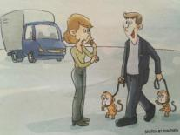
15. On his way to the city, the man saw a lady with two monkeys and stopped.
16. The lady paid the man to take the monkeys to the zoo.
17. It took the lady five hours to fix her truck (卡车).
18. After fixing her truck, the lady drove to the zoo to meet the man.
19. The woman was very surprised to see the man and the monkeys in the street.
20. The man took the monkeys to Sea World instead of the zoo.
D. Listen to the note and complete the following sentences (听通知，完成下列内容，每空格限填一词): (10分)
21. The chemistry lab in __________ __________ will be closed until Friday.
22. The accident happened __________ __________ when a water pipe broke.
23. A lab table __________ __________ after water weakened its legs.
24. The electrical problem caused a __________ __________ in one corner of the lab.
25. The lab will reopen only for __________ __________.

Part 2 Phonetics, Grammar and vocabulary

（第二部分 语音、语法和词汇）
Ⅱ. Choose the best answer (选择最恰当的答案): (共20分)
26. Which of the following underlined part is different in pronunciation from others?
A) My father is of medium height. B) Tom could never keep a secret.
C) She is a senior lecturer at the university. D) These steps go down to the garden.
- He goes to a special school for deaf children. Which of the following is correct for the
underlined part?
A) /s/ B) // C) /tS/ D) /Z/
28. More than half a million ______ are sent from Britain to Europe every year.
A) wolf B) panda C) tiger D) sheep
29. The theme park opens at 10.00 a.m. daily 7 days a week throughout the year, closing only
______ Christmas Day.
A) in B) for C) on D) at
30. Apologizing to those you love is one of ______ things you must do to maintain a friendship.
A) important B) more important C) most important D) the most important
31. Online maps make ______ easy to locate any place in the world.
A) this B) that C) one D) it
32. We tried to stop him ______ climbing the mountain on his own.
A) from B) by C) with D) for
33. There are many ways to calm your pets and keep them ______ during the storm.
A) save B) safe C) safety D) safely
34. The hotel is in a good location, where you ______ go everywhere in a short time.
A) can B) may C) must D) should
35. Children’s situation in China ______ a lot in the past ten years.
A) improve B) improved C) has improved D) will improve
36. My uncle promised he ______ a postcard from Egypt.
A) sent B) will send C) would send D) has sent
37. There are no more chairs available, ______ you'll have to stand.
A) or B) but C) for D) so
38. Why don’t we encourage our children ______ off the video games and pick up a book?
A) turn B) turning C) to turn D) to turning
39. Thomas' story about ______ a bear attack was really exciting.
A) survive B) surviving C) to survive D) to surviving
- You will soon get out of practice ______ you play the piano regularly.
A) unless B) though C) because D) so that
41. The plane finally landed and not a single passenger ______.
A) killed B) had killed C) was killed D) will be killed
42. – In the Wizarding World, you can see buildings from the Harry Potter films.
– ______ dream place for Harry Potter fans!
A) How B) What C) What a D) What an
43. The police stop a car that has taken the wrong road. The driver gets a fine (罚款). Which sign might the driver have missed?
A) B) 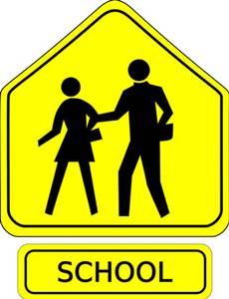 C) 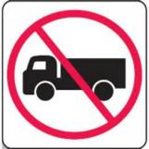 D)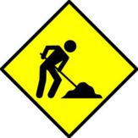
44. – Would you like me to help you on your new project?
– ______
A) Yes, I’d love to. B) Sure! That would be great!
C) Of course I would. D) I’m sorry to disturb you.
45. – You have to turn off your mobile phone. This is the class rule.
– ______
A) OK. Thank you for letting me know. B) Yes, I’ll take your advice.
C) I couldn’t agree with you more. D) Sorry, I didn’t hear that.
Ⅲ. Complete the following passage with the words or phrases in the box. Each word or phrase can only be used once（将下列单词或词组填入空格。每空格限填一词，每词或词组只能填一次）:（共8分）
A. keen B. items C. noticed D. nervous E. order

Shop owners around the world are getting increasingly annoyed with the latest trend of customers coming into their shops just to try things on, but not to buy. They have decided to do something to stop it.
As online shopping has become more and more popular, some shop owners have 46 that although their shops look busy, they aren’t making much money. This is because customers are 47 to save money by buying online but are worried about choosing the wrong size or colour. So they go to stores to try on clothes before going home to 48 them from a website.
But now stores in Australia have come up with an idea to stop this. They are asking customers to pay a ‘trying on’ fee. Winter sportswear shops have introduced charges (收费) of up to $50 to try on boots or other ski wear. This charge is returned if customers come back to buy the 49 within seven days.
A. effort B. fare C. fair D. at all E. seriously

It isn’t just ski wear; some bridal (新娘的) shops have also introduced charges. Martha Jones, owner of Wedded Bliss, a bridal shop in Melbourne, explains, “we get a lot of people who are not here to buy dresses 50 . Either they try on in-store and then shop online, or they are girls who are not even getting married; they just want to see what they look like in different wedding dresses. Fitting a woman for her wedding dress is a specialist skill that we take very 51 , and we put in time and 52 to make sure the dress is exactly right.’ The fee has been successful: ‘We’ve had fewer time-wasters,’ explains Jones, ‘which means we have been able to give our real customers an even better service.’
Would you pay to try on clothes? Do you think it is 53 to charge brides to try on dresses? Let us know in the comments section below.
Ⅳ. Complete the sentences with the given words in their proper forms（用括号中所给单词 的适当形式完成下列句子，每空格限填一词): (共8分)
54. As a young girl, she and her brother would help __________ parents in the cotton field. (they)
55. Against the Odds is the real-life story of a man in his __________ achieving the impossible.
(sixty)
56. It is much __________ for parents to find a good-performing school for their children. (hard)
57. Many of the __________ soldiers were not receiving needed medical care. (wound)
58. __________ yellow and blue paint together to make green. (mixture)
59. As we were leaving the train, he thanked me __________ for spending the time talking with
him. (polite)
60. He was trying to __________ his house after it was destroyed by a storm. (build)
61. There is no simple __________ to the country's population problem. (solve)
Ⅴ. Rewrite the following sentences as required（根据所给要求，改写下列句子。62-67题,每空格限填一词。68题注意句首大写): (共14分)
62. On Sundays, he seldom stays in the house. (改为反义疑问句)
On Sundays, he seldom stays in the house, __________ __________?
63. This jacket is mine. (对划线部分提问)
________ ________ this jacket?
64. If you have a question, please raise your hand. (保持句意基本不变)
If you have a question, please __________ __________ your hand.
65. He spread all his books and papers all over the table. (改为被动语态)
All his books and papers _________ _________ all over the table.
66. People used to eat more bread than they do nowadays. (保持句意基本不变)
People don't eat __________ __________ bread as they used to.
67. “Who teaches you physics?” my friend asked. (改为宾语从句)
My friend asked ________ ________ me physics.
68. will search, the police, anyone missing, the building, for (连词成句)
_______________________________________________.

Part 3 Reading and Writing (第三部分 读写)
Ⅵ. Reading comprehension (阅读理解): (共50分)
A. Choose the best answer（根据短文内容，选择最恰当的答案): (14分)
When the plane arrived on Prince Edward Island in Canada, the snow was thick on the ground as they’d had about 100cm in 24 hours. That amount of snow was unusual for the island but I didn’t know that so I wasn’t worried. It didn’t look much thicker than snow I’d seen in Scotland. I was going to visit my friend, Chris, and he’d warned me it would be very cold and snowy. In fact I was feeling too warm as I had too many clothes on.
Chris met me in his car and we were quite near his house, which was only five kilometers from the airport, when we got stuck in the snow. So we phoned the road rescue services and a man and a truck arrived. He said we were the fifth car he’d pulled out of the snow that evening. He started the engine and he’d almost pulled us out ... Only to find that the truck had brought a whole pile of snow down from the sides of the road onto both vehicles and the truck was stuck too. He phoned to get an even larger truck to come and rescue us all. In the end it did!
Chris turned off the engine and we sat in the car to wait for the second truck to pull us out. I suggested he might keep the engine running so we could stay warm. He pointed out that the gas gauge was showing nearly empty and he was worried that we still had to get to his house. We finally arrived at his house at 4.30 in the morning -five hours after leaving the airport.
69. When she got off the plane, the writer ______.
A) was afraid about the journey she had to make
B) was excited at seeing so much snow
C) realized the weather was colder than she expected
D) thought the snow wasn’t a problem for her
70. Why didn't the first truck get them out of the snow?
A) Its engine wasn’t strong enough. B) The driver was not experienced enough.
C) It knocked more snow on top of the car. D) It couldn’t get close enough to the car.
71. What does the underlined part ‘it did’ refer to?
A) A larger truck came to help us. B) The truck pulled our car out.
C) Someone answered the phone. D) The first truck got stuck.
- What was Chris worried about while they were waiting?
A) The truck might not be able to find them. B) It was midnight and they might get too cold.
C) The car engine might not start again. D) They might not have enough gas to get home.
- Why do you think the author wrote this piece?
A) To give advice about driving in the snow. B) To describe an event that happened to her.
C) To give thanks to Chris and truck drivers. D) To suggest a visit to Prince Edward Island.
- Which of these postcards would the writer send the next day?
A) B)
We got stuck in the snow on the way back from the airport and it took two trucks to get us out.
The journey from the airport was much longer than usual because of the snow. I travelled to Chris’s house in a truck in the end.

C) D)
We had to phone for the rescue services because we ran out of gas on the way back from the airport. The journey took five hours!
When I arrived here, it had snowed heavily so Chris wasn’t able to fetch me from the airport until later.

B. Choose the words or expressions and complete the passage（选择最恰当的单词或词语完成短文):（12分）
Everyone knows something about the USA and the Americans. But films and television often give the wrong idea about the country and its people.
People
The popular stereotype of Americans is that they are rude and 75 a lot - especially at sports events! In comparison with the British, Americans are more informal. 76 , they often call teachers by their first names. However, many Americans are like people in other countries - polite and helpful, especially with foreigners.
Food
The size of meals in American restaurants is very large, especially compared to the UK. And if you can’t finish your meal, it’s 77 to ask to take some home with you. This is completely different from the UK! And don’t forget to leave a tip in restaurants and bars. This is very important - you should leave about 15% of the bill.
Holidays
Americans don’t get much holiday. Most people have about two weeks of holiday each year. This is quite unlike other western countries. The average is about four weeks of holiday. However, Americans also have about ten national holidays each year. This is 78 most countries.
Living costs
Compared with the UK, the USA is 79 a lot cheaper for clothes, eating out, entertainment and much more! But the cost of renting (租) a flat is much the same as the UK and is quite expensive in big cities.
80
The USA is a huge country and there are four different time zones in the USA. So when it’s 10 a..m. in New York, it’s 7 a.m. in San Francisco. Don’t forget this when you’re phoning someone! In comparison with the north, winters in the south are not usually very cold. Check the weather in the area you are going to.

75. A) smile B) shout C) move D) sleep
76. A) What’s more B) On average C) For example D) After all
77. A) unusual B) common C) necessary D) stupid
78. A) familiar to B) different from C) similar to D) connected with
79. A) generally B) actually C) hardly D) possibly
80. A) Clothes B) Manners C) Size and location D) Time and temperature

C. Read the passage and fill in the blanks with proper words（在短文的空格内填入适当的词，使其内容通顺，每空格限填一词，首字母已给):（14分）
In the past few decades, a large number of new electronic devices have appeared: MP3 players, camcorders, e-book readers, and so on. Will the future bring new gadgets (小玩意)? Perhaps, but many experts believed that the number of gadgets will actually d 81 as people do more and more things with just one device: the smart phone.
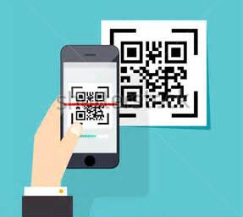
This c 82 has already happened in Tokyo. There, mobile phones are making travelling much easier and f 83 . Imagine you are waiting at a Tokyo bus stop. If you use the camera on your smart phone to take a photo of a special icon (图标) on the bus stop, the timetable appears on your s 84 . When the bus arrives, you use the same phone to pay for your ride.
At airports, it’s even more useful. You don’t need a t 85 or a boarding pass - with just your phone, you can be on your plane only 15 minutes after arriving at the airport. And at hotels, the phone allows you to pay for the room w 86 using a credit card or money. It even opens your hotel room door!
The phone a 87 helps you find the way when you’re on foot. If you hold it in your hand, it tells you which way to go. This is especially useful in Tokyo, where it’s so easy to get lost!
D. Answer the questions（根据短文内容回答下列问题): ( 12分)
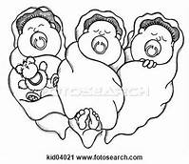
As soon as people realize that my brother Michael, my sister Tiffany and I were born on the same day, that we’re triplets, they ask the strangest questions. But no, we can’t read each other’s minds. We don’t have the same dreams. And I can promise you that we don’t always get along. These are the things I get asked most often when people meet me for the first time.
Although there are lots of good things about being a triplet, one thing I really don’t like is when people think of us as one person - ‘MichaelDesireeTiffany’ instead of ‘Michael’ and ‘Desiree’ and ‘Tiffany’. I don’t like it when people think we should act or think the same just because we were born at the same time, like when people ask me why I’m so shy while Michael and Tiffany are so much louder. And I definitely don’t like it when people don’t understand that we have individual (个人的) choices of what to do in our spare time.
Growing up, Tiffany, Michael and I shared almost everything. It was funny how the exact moment I wanted to use the bike was the same time that Tiffany felt like going for a ride. When the three of us learned to drive at the same time, we very often fought over who got to practise with the car.
My dad came up with a brilliant plan called ‘turns’. One Sunday a month, each of us would have a chance to spend three hours with our dad, alone, and do whatever we wanted. For three hours every month each of us was allowed to feel like he/she was an only child. This helped me to see that being a triplet is a part of me, but it isn’t the only part of me. I don’t just want to be thought of as ‘Desiree, the girl who’s a triplet’. I want to be thought of as an individual.
88. Is Desiree the only girl of the triplets?
89. What question might people ask the triplets when they first meet them? Give one example.
90. How did they decide who practised with the car first?
91. How often could each of the triplets have the “alone time” with their father?
92. In what ways are the triplets different? (List 2)
They have different __________ and __________.
- What are the bad things about being a triplet?
Ⅶ. Writing (作文): (共20分)
- In 60 to 120 words, write about the topic “Memories”. ( 以“回忆”为题，写一篇60-120个词的短文，标点符号不占格)

The following questions are for reference only. (以下问题仅供参考)
- What do memories mean to you?
- What are the things that bring back your memories?
- How do you record your memories?

（ 注意：短文中不得出现考生真实的姓名、校名及其他相关信息，否则不予评分。）

