浦东新区2015学年第二学期初三教学质量检测
英语试卷
（满分150分，考试时间100分钟）
考生注意：本卷有7大题，共94小题。试卷均采用连续编号，所有答案务必按照规定
在答题纸上完成，做在试卷上不给分。
Part l Listening (第一部分 听力)
I．Listening Comprehension (听力理解) (共30分)
A. Listen and choose the right picture (根据你听到的内容，选出相应的图片) (6分)
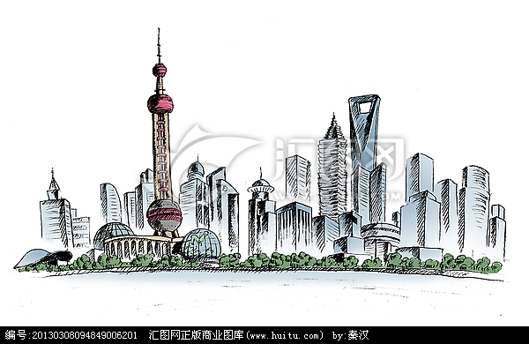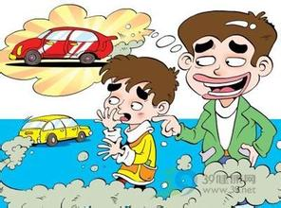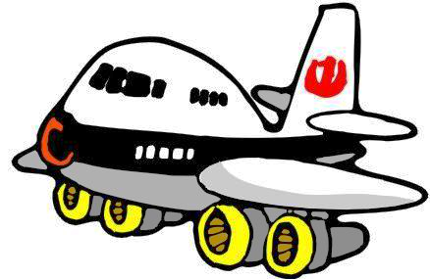

A B C D
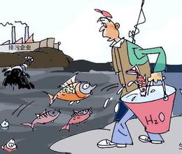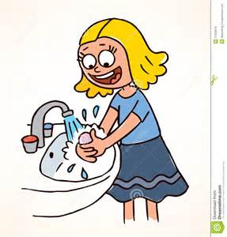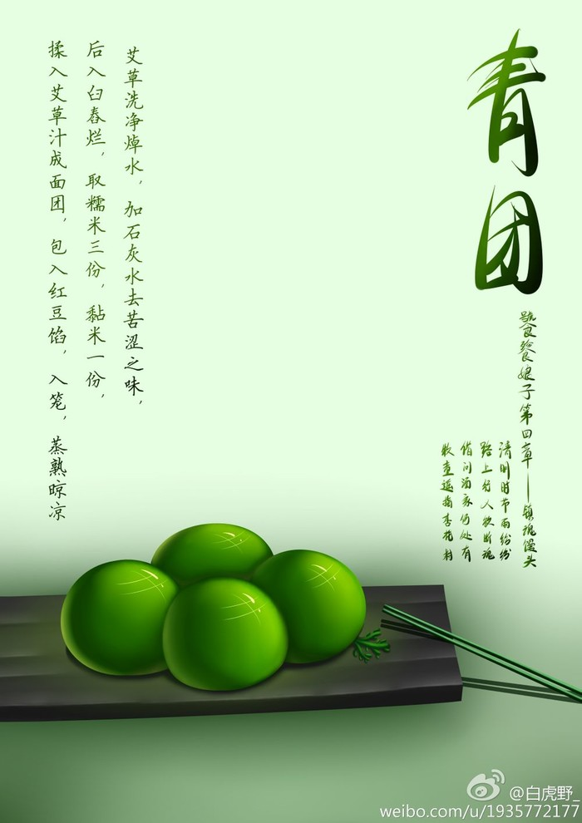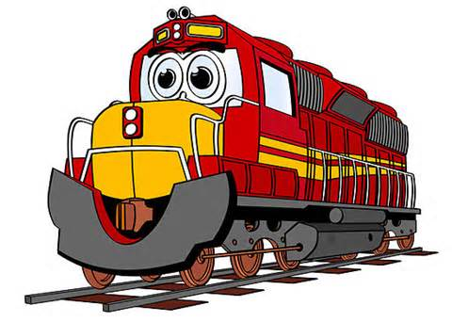

E F G H
1.________ 2.________ 3. ________ 4. ________ 5. ________ 6.________
B．Listen to the dialogue and choose the best answer to the question you hear (根据你听到的对话和问题，选出最恰当的答案) (8分)
7. A) Jerry. B) Jessica. C) John. D) Jane.
8. A) Coffee. B) Coke. C) Tea. D) Juice.
9. A) A bus station. B) A train station. C) An airport. D) A supermarket.
10. A) 500 yuan. B) 1000 yuan. C) 1800 yuan. D) 900 yuan.
11. A) Teacher and student. B) Mother and son.
C) Wife and husband. D) Waitress and customer.
12. A) A newspaper. B) A travel guide. C) A map. D) A book.
13. A) He has had a bad cold. B) He has had a headache.
C) He didn’t put on his coat. D) He didn’t close the windows.
14. A) She will go by bus. B) She will go on foot.
C) She will go by car. D) She will go by bike.
C. Listen to the passage and tell whether the following statements are true or false (判断下
列句子是否符合你听到的短文内容，符合的用“T”表示，不符合的用“F”表示) (6分)
15. This is a brief introduction of an exciting physics project.
16. The bridge that the students are going to see was built in 1832.
17. A famous engineer built the bridge and also paid for it.
18. Two dollars is enough for students to get into the Bridge Museum.
19. Students need no food or drink, but a camera for the trip.
20. May 9 is the date that the students will have the trip to the bridge.

D．Listen to the passage and complete the following sentences. (听短文，完成下列内容。每空格限填一词) (10分)
21. The teachers tried different ways to get the bird, but ________ ________.
22. Lisa ________ ________ call her student Mary for help.
23. Mary couldn’t catch the bird until it was sitting on ________ ________.
24. The town locates ________ ________ away from Mary’s home.
25. Mary ________ ________ that the bird wants to find its owner.

Part 2 Phonetics, Grammar and Vocabulary
(第二部分 语音、语法和词汇)

Ⅱ. Choose the best answer (选择最恰当的答案) （共20分）
26. The smoke from the factory made us feel sick. Which of the following is correct for the underlined word?
A) [smɒk] B) [smɒ:k] C) [smaʊk] D) [sməʊk]
27. Which is _____ favorite monkey character, Abu or Monchhichi?
A) she B) her C) hers D) herself
28. Paris, _____ other big cities, is going to make better use of its river.
A) like B) of C) except D) from
29. In the US, the one-way trip to the workplace takes 24.4 minutes _____ average.
A) in B) on C) around D) with
30. Playing ball games is a good way for the students of the _____ grade to release stress.
A) nine B) nines C) ninth D) ninths
31. My father doesn’t like the food others cook at all. He _____ goes to the restaurants.
A) never B) often C) sometimes D) always
32. Stick to your dreams, _____ they will come true one day.
A) so B) or C) too D) and
33. _____ this is your first visit to New York, you’d better learn some of the customs.
A) Unless B) Since C) Although D) Until
34. John was so sleepy that he could hardly keep his eyes _____.
A) open B) opened C) to open D) opening
35. By the time I got to the check-out, I realized that I _____ my purse at my office.
A) have left B) had left C) left D) was leaving
36. Scientists warn that El Niño _____ the world this coming summer.
A) damaged B) had damaged C) was damaging D) will damage
37. People _____ to set off firecrackers in some areas of Shanghai for several months.
A) aren’t allowed B) weren’t allowed
C) won’t be allowed D) haven’t been allowed
38. Mother encouraged the little Tom _____ his special experience in the blog.
A) share B) to share C) shared D) gain
39. People should _____ into the habit of garbage sorting(垃圾分类) in neighborhood.
A) get B) give C) go D) grow
40. If you find free WiFi in public places, you _____ a password.
A) needn’t B) don’t need to C) needn’t to D) don’t need
41. Rio de Janeiro still has a lot of things _____ to prepare for the 2016 Olympics.
A) do B) did C) to do D) does
42. _____ lovely robot! Actually, it is a smartphone, the RoBoHon.
A) What B) What a C) How D) How a
43. —If I go to the UK, _____ must I try?
—Fish and chips.
A) Whose B) What C) When D) Who
44. —Mum, I’m afraid the work is too difficult for me.
—_____
A) I believe you can do it! B) You are welcome.
C) Well done! D) Thank you so much.
45. —Let’s buy a gift for Mother.
—_____
A) Not exactly. B) That’s a good idea.
C) What a pity. D) It doesn’t matter.

Ⅲ. Complete the following passage with the words or phrases in the box. Each can be used
only once (将下列单词或词组填入空格。每空格限填一词，每词只能填一次) (共8分)

A. private B. in C. playing D. every day E. looking for

For those who don’t like to open their wallets, a new paying service---Apple Pay---is available now.
Paying 46 stores or within apps has never been easier or safer. The days of 47 your wallet will be away from you. Apple Pay is simple to use and works with the cards you already have on the devices you use 48 . And because your card details are never shared when you use Apple Pay — in fact, they aren’t stored on your device at all — using Apple Pay on your iPhone, Apple Watch, or iPad is the safer and more 49 way to pay.

A. complete B. fifth C. problem D. instead of E. complain

Apple started the service with China Union Pay on Feb 18, making China the 50 country in which the service can be used after the US, the UK, Canada and Australia.
Apple Pay users can 51 a deal by just moving their devices near point of sale (POS) terminals 52 scanning a bar code which is required by mobile payment services. The near-field communication technology or NFC allows the contactless data exchange between the user’s device and the POS terminal.
People may pay close attention to Apple Pay at first, but the main 53 for Apple Pay is how to attract more people in the run.

Ⅳ. Complete the sentences with the given words in their proper forms (用括号中所给单词
的适当形式完成下列句子。每空格限填一词)(共8分)
54. The old pictures in the hall have been taken down, and new _________ will be put up. (one)
55. Mohammed Ali enjoys _________ on the course of programming. (he)
56. The _________ soldiers were sent to the nearest hospital at once. (wound)
57. Once you have made your _________ , you can’t change it. (choose)
58. Airlander 10, the _________ aircraft in the world, is preparing for its first test flight. (large)
59. It’s a piece of cake. I can finish it _________ tonight. (easy)
60. We all know that a _________ driver is a danger to the public. (care)
61. If you can’t _________ in the exam, what will you do next? (success)

Ⅴ. Complete the following sentences as required (根据所给要求完成句子。62-67小题每空格限填一词) (共14分)
62. Technologies can be part of everyday education in the future. (改为一般疑问句)
________ technologies ________ part of everyday education in the future?
63. She has kept the little dog since she found it in the street. (划线部分提问)
________ ________ has she kept the little dog?
64. Young students like electronic books better than paper books. (保持句意不变)
Young students ________ electronic books________ paper books.
65. We are all interested to know where we can register to attend MOOCs. (改为简单句)
We are all interested to know ________ ________ register to attend MOOCs.
66. The gardener waters the plants in his garden every day. (改成被动语态)
The plants in his garden ________ ________ by the gardener every day.
67. “Will they go to the airport by Didi Dache car service?” little Jenney asked. (改为宾语从句)
Little Jenney asked ________ ________ would go to the airport by Didi Dache car service.
68. can, you, the difference, seeing and hearing, between, tell (连词成句)
?

Part 3 Reading and Writing (第三部分 读写)
VI. Reading comprehension (阅读理解) (共50分)
A．Choose the best answer (根据短文内容，选择最恰当的答案) (12分)
Carole’s Cooking Journal
Monday, April 6
This month, we had to choose an optional activity. Should it really be called “optional” if you have to do it? Unfortunately, I waited until the last minute to sign up. Many of the activities were already full, but I made a decision to join the Cooking Club because at least that way I would get a snack to eat.
Tuesday, April 7
It was the first time to be here. Like many of my ideas, joining the Cooking Club made sense at first but was turning out to be a disaster. Most people have been in the club for more than a year, so they already know what they’re doing. And since they all know each other, they weren’t exactly interested in a newcomer.
Thursday, April 9
What a terrible day! How could I know that if a recipe says to beat cookie batter (糊), you couldn’t do it with your fists (拳头)? I thought the other kids would never stop laughing. And it was not easy to get cookie batter off your clothes.
Friday, April 10
I have more funny things in Cooking Club. Now I know that chocolate mousse is a dessert and it isn’t spelled m-o-o-s-e. “Mousse” and “Moose” (驼鹿) sound exactly the same. So I don’t think my question about whether vegetarians(素食者) can eat chocolate mousse was really that silly.
Monday, April 13
One of my bright ideas worked out for a change! Everyone laughed when I handed out the chocolate “moose” cookie that I made yesterday, but this time I was laughing, too. The peanut butter antlers(鹿角) were a huge hit. We’re even planning to bake more cookies for the school food festival next week.
69. Carole chose the Cooking Club because _________.
A) She liked making different kinds of food.
B) Cooking club was the only activity she could choose.
C) She could get some food in the Cooking Club.
D) It was not open to the students until the last minute.
70. How did Carole feel when she joined the club for the first time?
A) Excited. B) Frightened. C) Pleased. D) Lonely.
71. Why did the writer beat the cookie batter with her fists?
A) Because she was upset about being in the club.
B) Because she misunderstood a cooking recipe.
C) Because she didn’t know how to use tools.
D) Because she was laughed at by other kids.
72. What did Carole think of mousse at beginning?
A) She thought eating mousse was silly.
B) She thought mousse was a kind of animal.
C) She thought mousse didn’t taste good.
D) She thought only vegetarians can eat mousse.
73. The underlined word “huge hit” is the closest in meaning to “ ”.
A) great success B) sweet dessert
C) big disaster D) beautiful decoration
74. How long has Carole been in the Cooking Club according to the journal?
A) About one week. B) About one month.
C) About two weeks. D) About two months.

B．Choose the best words and complete the passage (选择最恰当的单词完成短文) (12分)
In Chinese, it is known as the “precious land”. Full of mountains and Karst landforms (地貌), Guizhou has remained one of China’s unspoiled places.
Last month, the southwestern province was chosen as one of the 52 75 places to go in 2016 by the New York Times.
Now Guizhou is starting to present its real feel to more visitors. The opening of the Guiyang-Guangzhou high-speed railway on Dec 26, 2014 has 76 the rail journey from more than 20 hours to only about four hours.
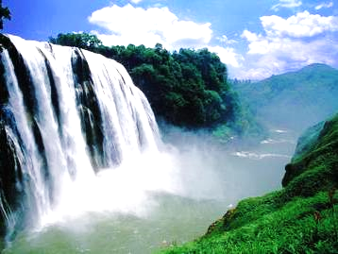 As the China Tour Guide website noted, Guizhou’s beautiful natural scenery is “a wonderland that you will never forget”. The most famous scenic spot is probably the Huangguoshu Waterfall. The noise of the waterfall can be heard 77 with huge amounts of water falling down it. It’s the largest waterfall in Asia, which is 77.8 meters high and 101 meters wide. The sunlight and rainbows also 78 the waterfall’s beauty, which seems to come from another world.
Another eye-catching Guizhou attraction is its colorful locals. The fact that people couldn’t get to the province for years helped many ethnic groups（少数民族）keep their 79 lifestyles and cultures. For example, Miao people still live in wooden houses on stilts (木桩), while the Dong people have old wind and rain bridges, giving people shelter when it rains.
While 80 is different for different ethnic groups, sour and spicy tastes are common in Guizhou cuisine. With its use of tomatoes and just a touch of chili peppers, it is loved by anyone unwilling to the spicier Sichuan cuisine.
75. A) top B) clean C) big D) kind
76. A) raised B) widened C) cut D) delayed
77. A) quickly B) clearly C) weakly D) smoothly
78. A) take away B) put on C) keep off D) add to
79. A) international B) fashionable C) traditional D) new
80. A) food B) house C) living D) dressing

C. Read the passage and fill in the blanks with proper words (在短文的空格内填入适当的词，使其内容通顺。每空格限填一词，首字母已给) (14分)
Throughout the 1900s, almost everyone knew how to jump, or “skip” rope. And it wasn’t just kids on playgrounds chanting silly rhymes or singing favourite songs. Champion boxes like Sugar Ray Leonard and Muhammad Ali jumped rope to build stamina (耐力) and develop quick footwork.
The activity of rope-jumping for f 81 and exercise has most likely been around for thousands of years. Historians believe children skipping rope, and medieval (中世纪的) European paintings s 82 children skipping rope on the cobblestone (鹅卵石) streets.
The earliest jump ropers in North America may have been Dutch immigrants, who brought the game Double Dutch with them in the 1600s. In Double Dutch, two turners h 83 the ends of two ropes and turn them in opposite directions as one person jumps between them. When the game was first introduced, girls couldn’t participate, partly because they were c 84 weaker, and exercise was thought of as unfeminine (不适合女性的). Also, girls wore l 85 dresses that got in the way.
Once girls did start jumping, however, they really took over. And later, it was m 86 girls who were better at this activity. Now, both girls and boys jump rope. Jumping rope has become a worldwide competitive sport in which children and adults compete in both single and t 87 events.
So, pick up a rope, find a silly rhyme or your favorite song, and start jumping.

D. Answer the questions (根据短文内容回答问题) (12分)
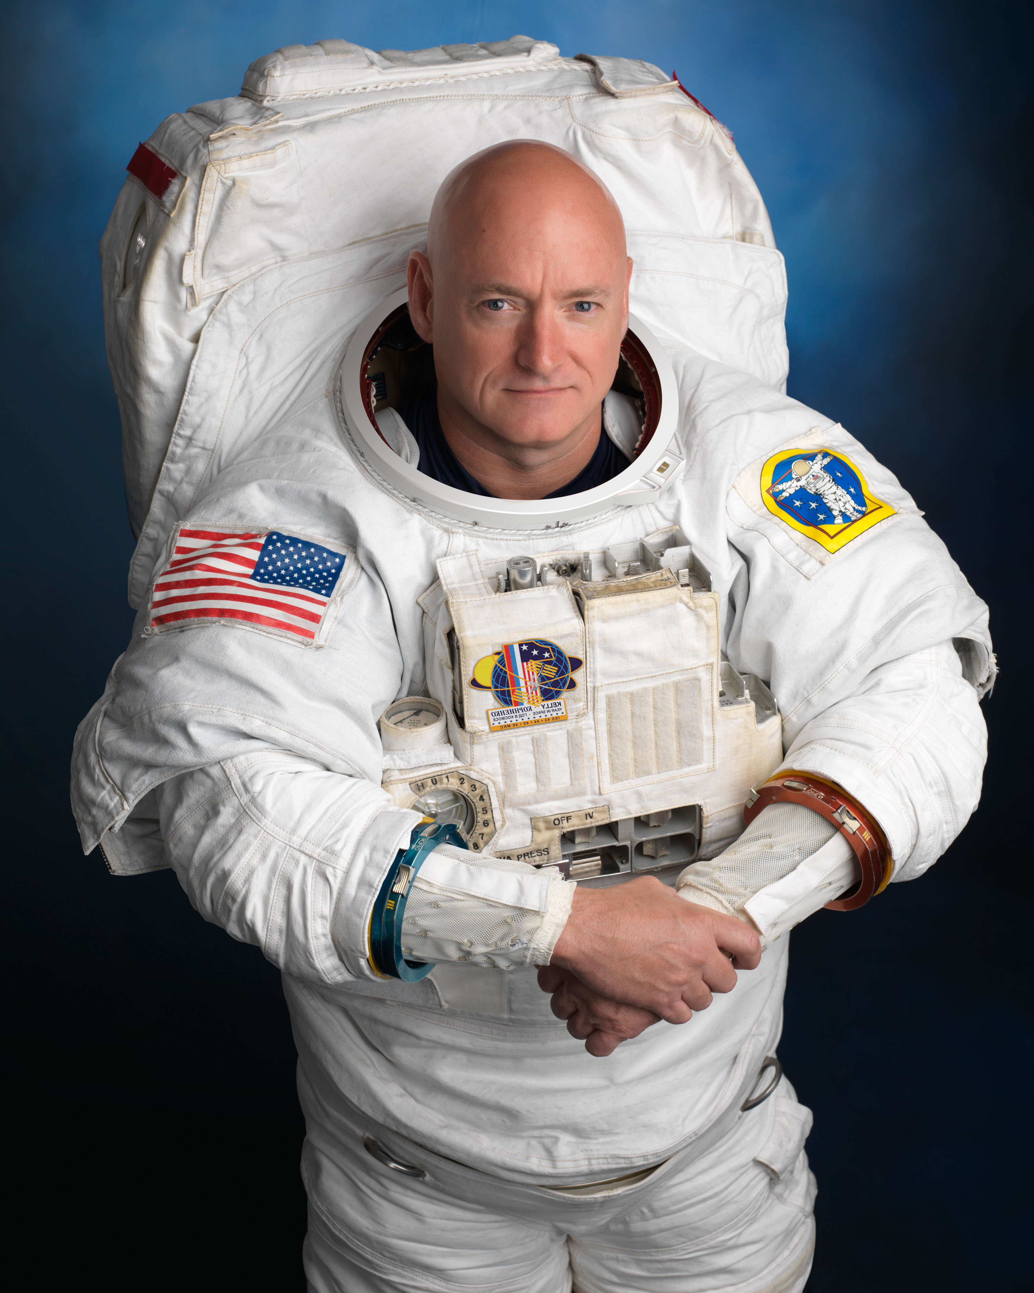Scott Kelly, an American astronaut, returned to earth on March 2, 2016. He was taller by nearly 1.5 inches (3.81 cm) when he landed on Earth after his 340-day space mission on the International Space Station (ISS).
His change in height, which lasted about two days, raised the question: What are the effects of a long-term stay in space?
As you probably know, there is no gravity in space. This not only causes difficulties in everyday actions like eating, walking and sleeping, but also problems for the human body.
The first problem is the air. Without gravity, carbon dioxide cannot spread during breathing, but gathers around the body and causes headaches. More than that, human feelings of movement are affected, which could make people feel sick.
The body’s fluids(液体) don’t work well in weightlessness, making blood flow upward instead of down to the lower legs, and astronauts’ faces become fatter than normal. Gaps between bones also become larger because humans cannot stand up straight. The spine(脊柱) can also get bigger in zero gravity.
In addition, human bodies become weaker because of the lack of gravity and space to move around in. Some astronauts said that after they returned, their muscles hurt and their skin became very sensitive(敏感的). Kelly said during his first press conference, “It was almost like my body was on fire wherever I sat or lay or walked.”
However, the research into the effects of long-term space flight on human bodies and minds never stops. There are many actions that astronauts can take in space. They can take vitamin D for bone growth, wear special belts on their legs to keep blood in their lower bodies and do strength coaches’ exercises. The fans in the ISS also help spread carbon dioxide around. “We will do further research.” NASA Administrator Charles Bolden said, “I believe it will be meaningful to human-being.”
88. Something occured to Kelly’s body when he finished his space mission, didn’t it?
89. People may _____________, if carbon dioxide cannot spread during breathing.
90. What will happen to astronauts’ faces in space?
91. Why did Kelly feel burned when he was sleeping according to the text?
92. What can astronauts do to keep fit in space?
93. Do you agree that the research is meaningful to human-being? Why?
VII. Writing（作文） （共20分）
94. Write at least 60 words on the topic “ A person ___________me before”
（以“曾经_________ 过我的人”为题，写一篇不少于60个词的短文，标点符号不占格）

很多人曾经出现在你的成长旅程中，他们或帮助你，或鼓励你，或爱护你，……
请你描述他（她）是怎样的人，以及发生在你和他（她）之间的故事，并谈谈他（她）对你的影响。

（注意：短文中不得出现任何真实人名、校名及其它相关信息，否则不予评分。）

